|  |  |  |  |
| --- | --- | --- | --- |
| SNO | **LIST** | **TUPLE** | **DICTIONARY** |
| 1. | A List is a collection of ordered data types. | A Tuple is a collection of ordered data types. | A dictionary is an unordered collection of data types that stores data in key-value pairs. |
| 2. | Lists are Mutable | Tuples are immutable | Dictionaries are mutable |
| 3. | Lists Allow duplicates | Tuples allow Duplicates | Dictionaries don’t allow duplicates. |
| 4. | Lists are declared within square brackets. | Tuples are enclosed within parentheses. | Dictionaries are enclosed within flower brackets. |
| 5. | Append() method is used to add a new item to the end of the list. | Tuples don’t allow new items to add where they are immutable. | Update() method in dict updates the dict with new key-value pairs |
| 6. | POP() method removes an item at given index in the list. | Tuples are immutable to change. | POP() method removes a particular item from the dictionary. |
| 7. | Sort() method used to sort the list in ascending or descending order. | Through tuples are ordered, the elements cannot be sorted. | Sort() method used to sort the keys in the dictionary by default. |
| 8. | Index() method used to search for a given element from starting of the list and returns the lowest index where element founds. | Index() method used to search for a specific element and returns the index value of that element. | Get() method returns the value of an item with the specified key. |
| 9. | Reverse() method used to reverse the all elements in the list | Reverse() method is not defined, as tuples are unchangeable. | Reverse() method is not defined, as dictionary are in the form of key-Value pairs. |
| 10. | Count() method returns the number of times a particular element appears in a list. | Count() method returns the number of times a particular elements occurs in tuple. | Count() method is not defined in the list. |

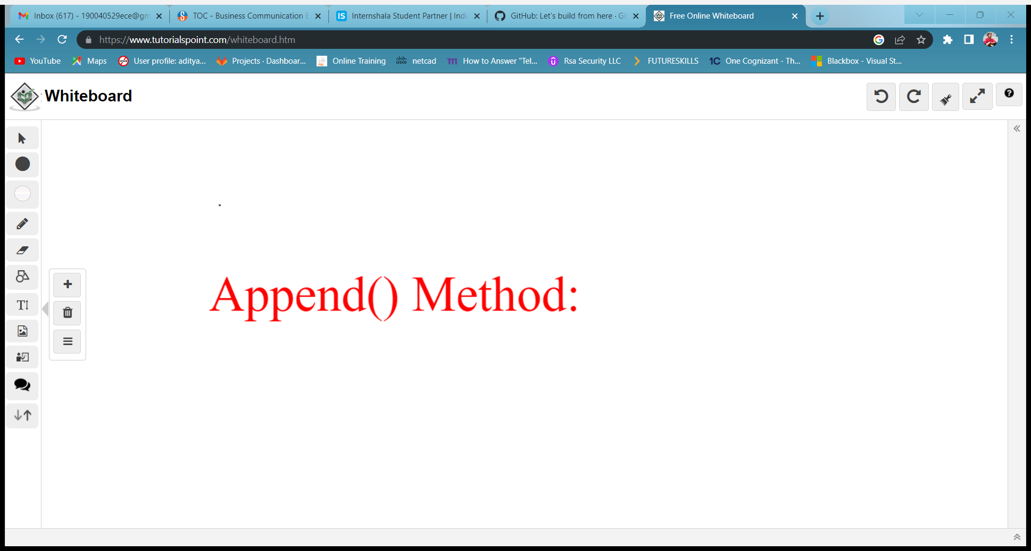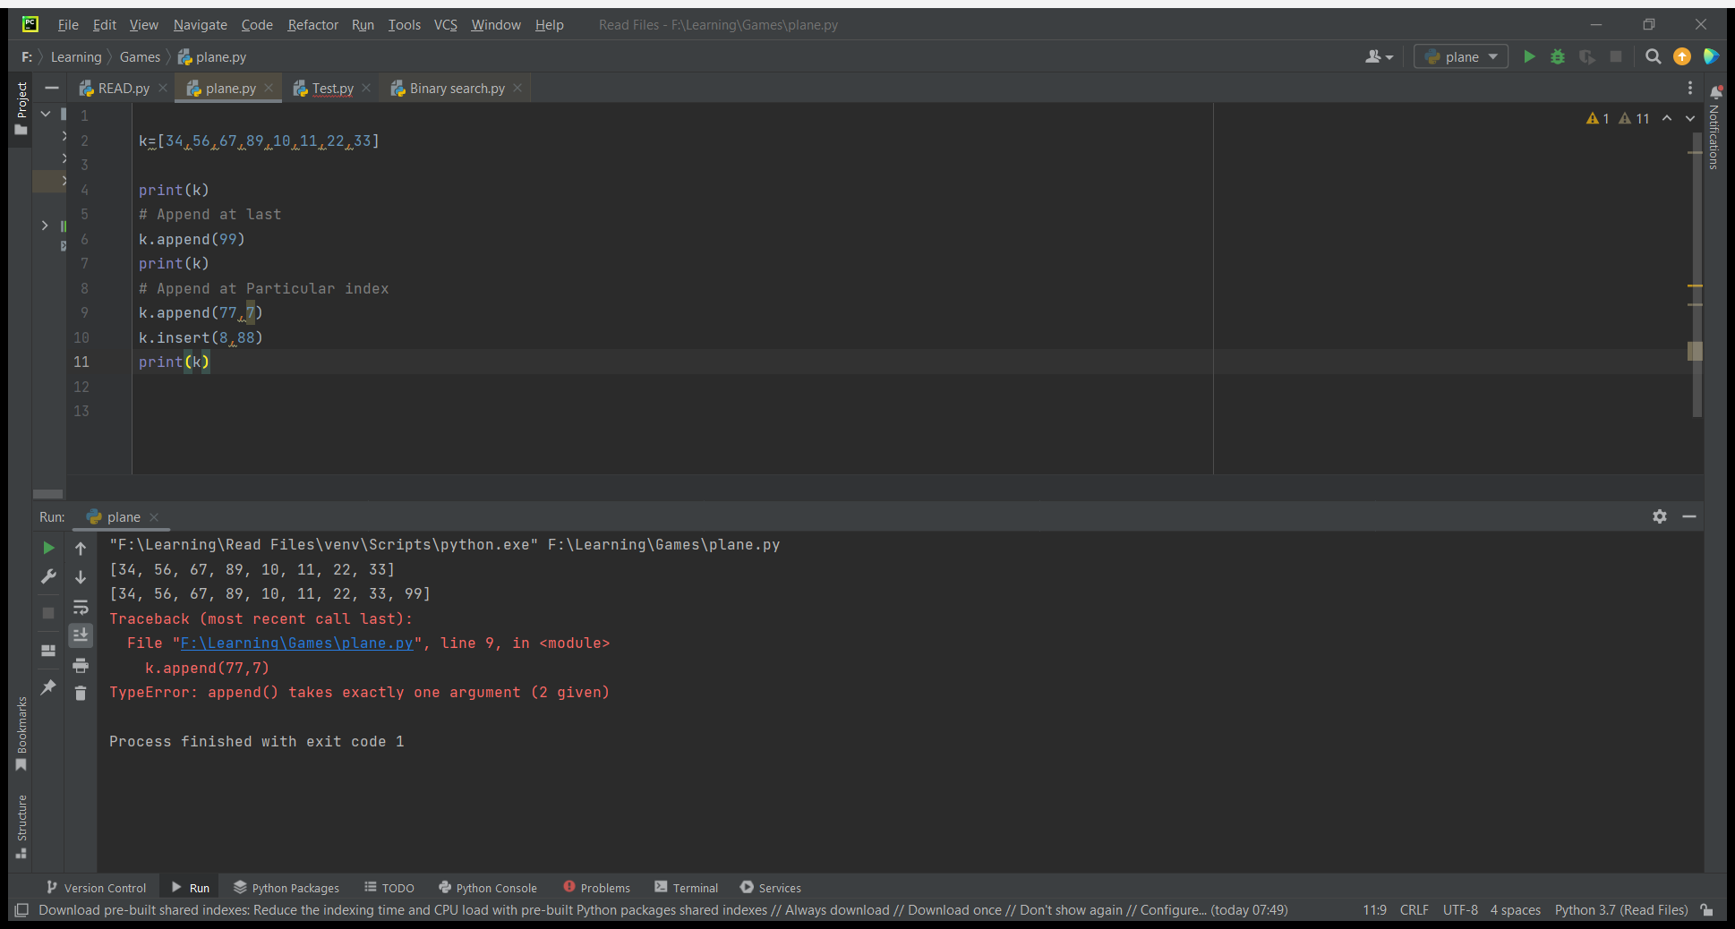

* List :

Append() is used to add an element at end of the list only.

* 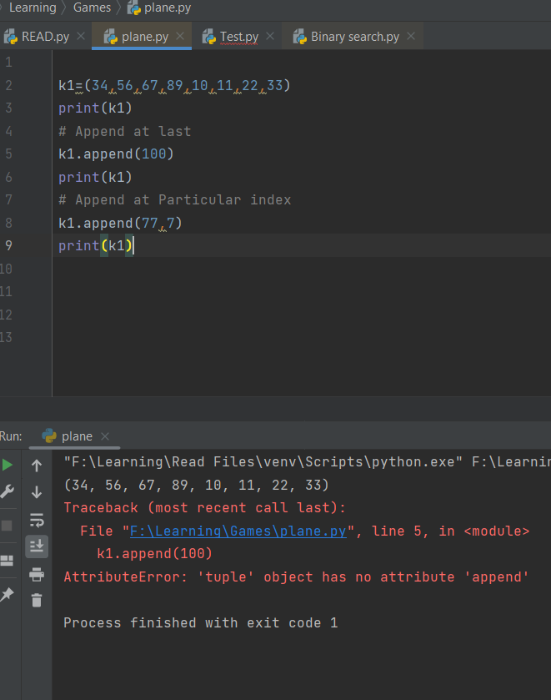Tuple :

Append() method doesn’t works with Tuple, due to tuples are immutable.

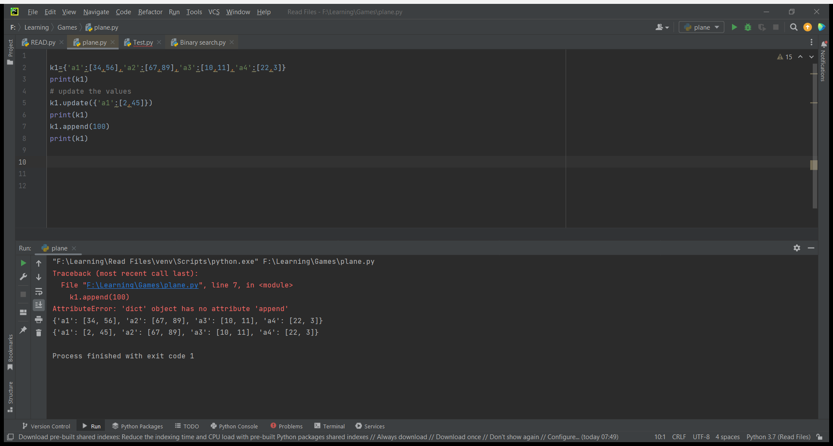

* Dictionary :

Update() method in dict updates

the dict with new key-value pairs